Enterprise Multi-AS BGP Network Design

Name: G. Koojana Sasmitha Gamage

Table of Content
Cover Page…………………………………………………………………………………...01
Table of Content……………………………………………………………………………...02
Fully Labelled Topology Diagram…………………………………………………………...04
IP Addressing…………………………………………………………………………………07
Written justification for the use of additional loopback interfaces and support protocols for BGP operation………………………………………………………………………………..09
Full Command Listing for Each Router……………………………………………………...10
- Router 1………………………………………………………………………………10
- Router 2………………………………………………………………………………12
- Router 3………………………………………………………………………………15
- Router 4………………………………………………………………………………18
- Router 5………………………………………………………………………………21
- Router 6………………………………………………………………………………24
- Router 7………………………………………………………………………………27
- Router 8………………………………………………………………………………30
- Router 9………………………………………………………………………………32
- Router 10……………………………………………………………………………..35
- Router 11……………………………………………………………………………..38
Comprehensive Test Plan…………………………………………………………………….42
Test Results for Test Plan…………………………………………………………………….44
- Test of Router 1………………………………………………………………………44
- Test of Router 2………………………………………………………………………46
- Test of Router 3………………………………………………………………………47
- Test of Router 4………………………………………………………………………49
- Test of Router 5………………………………………………………………………51
- Test of Router 6………………………………………………………………………53
- Test of Router 7………………………………………………………………………55
- Test of Router 8………………………………………………………………………57
- Test of Router 9………………………………………………………………………59
- Test of Router 10……………………………………………………………………..61
- Test of Router 11……………………………………………………………………..63
- Test Results of The Ping Command………………………………………………….65
Conclusion……………………………………………………………………………………67
Fully Labelled Topology Diagram
The network diagram that I designed to clearly show the router interconnections, AS boundaries, IP addressing and loopback interfaces.
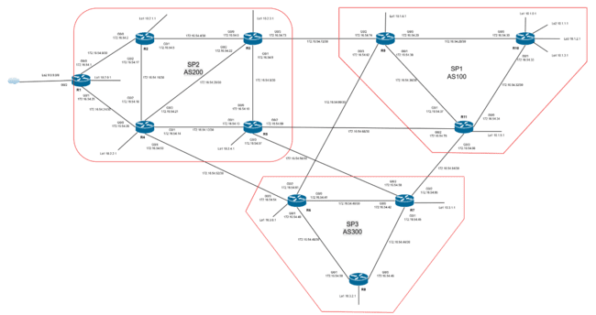
SP1
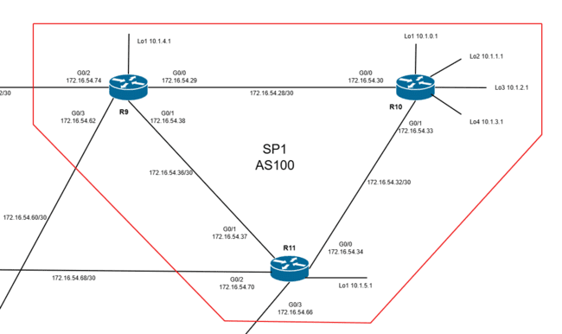
SP2
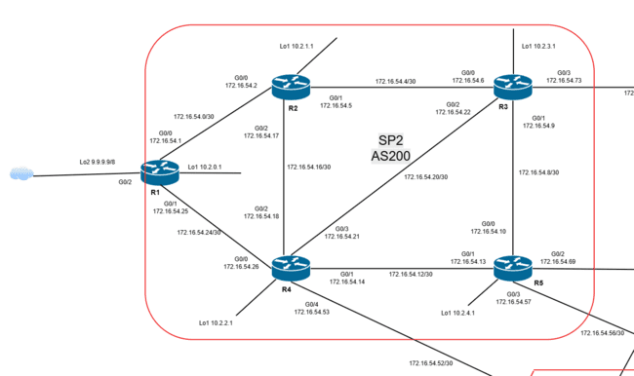
SP3
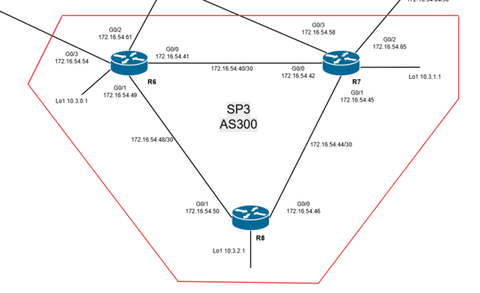
The network diagram which created using Cisco Modeling Lab.
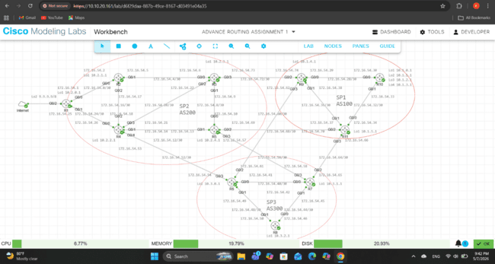

IP Addressing
The network was designed using the IP address range 172.16.54.0/24 for router-to-router communication. Then created the subnets using /30 subnet masks to efficiently allocate IP addresses for point-to-point links between routers.
IP Addressing Table
Connected Routers | Network Address | Router Interface | IP Address | Subnet Mask
R1 – R2 | 172.16.54.0/30 | R1 G0/0 | 172.16.54.1 | 255.255.255.252
 |  | R2 G0/0 | 172.16.54.2 | 255.255.255.252
R2 – R3 | 172.16.54.4/30 | R2 G0/1 | 172.16.54.5 | 255.255.255.252
 |  | R3 G0/0 | 172.16.54.6 | 255.255.255.252
R3 – R4 | 172.16.54.20/30 | R3 G0/2 | 172.16.54.22 | 255.255.255.252
 |  | R4 G0/3 | 172.16.54.21 | 255.255.255.252
R3 – R5 | 172.16.54.8/30 | R3 G0/1 | 172.16.54.9 | 255.255.255.252
 |  | R5 G0/0 | 172.16.54.10 | 255.255.255.252
R3 – R9 | 172.16.54.72/30 | R3 G0/3 | 172.16.54.73 | 255.255.255.252
 |  | R9 G0/2 | 172.16.54.74 | 255.255.255.252
R4 – R1 | 172.16.54.24/30 | R1 G0/1 | 172.16.54.25 | 255.255.255.252
 |  | R4 G0/0 | 172.16.54.26 | 255.255.255.252
R4 – R2 | 172.16.54.16/30 | R4 G0/2 | 172.16.54.18 | 255.255.255.252
 |  | R2 G0/2 | 172.16.54.17 | 255.255.255.252
R4 – R5 | 172.16.54.12/30 | R4 G0/1 | 172.16.54.14 | 255.255.255.252
 |  | R5 G0/1 | 172.16.54.13 | 255.255.255.252
R4 – R6 | 172.16.54.52/30 | R4 G0/4 | 172.16.54.53 | 255.255.255.252
 |  | R6 G0/3 | 172.16.54.54 | 255.255.255.252
R5 – R11 | 172.16.54.68/30 | R5 G0/2 | 172.16.54.69 | 255.255.255.252
 |  | R11 G0/2 | 172.16.54.70 | 255.255.255.252
R5 – R7 | 172.16.54.56/30 | R5 G0/3 | 172.16.54.57 | 255.255.255.252
 |  | R7 G0/3 | 172.16.54.58 | 255.255.255.252
R6 – R7 | 172.16.54.40/30 | R6 G0/0 | 172.16.54.41 | 255.255.255.252
 |  | R7 G0/0 | 172.16.54.42 | 255.255.255.252
R6 – R8 | 172.16.54.48/30 | R6 G0/1 | 172.16.54.49 | 255.255.255.252
 |  | R8 G0/1 | 172.16.54.50 | 255.255.255.252
R6 – R9 | 172.16.54.60/30 | R6 G0/2 | 172.16.54.61 | 255.255.255.252
 |  | R9 G0/3 | 172.16.54.62 | 255.255.255.252
R7 – R8 | 172.16.54.44/30 | R7 G0/1 | 172.16.54.45 | 255.255.255.252
 |  | R8 G0/0 | 172.16.54.46 | 255.255.255.252
R7 – R11 | 172.16.54.64/30 | R7 G0/2 | 172.16.54.65 | 255.255.255.252
 |  | R11 G0/3 | 172.16.54.66 | 255.255.255.252
R9 – R10 | 172.16.54.28/30 | R9 G0/0 | 172.16.54.29 | 255.255.255.252
 |  | R10 G0/3 | 172.16.54.30 | 255.255.255.252
R9 – R11 | 172.16.54.36/30 | R9 G0/1 | 172.16.54.38 | 255.255.255.252
 |  | R11 G0/1 | 172.16.54.37 | 255.255.255.252
R11 – R10 | 172.16.54.32/30 | R11 G0/0 | 172.16.54.34 | 255.255.255.252
 |  | R10 G0/1 | 172.16.54.33 | 255.255.255.252

Written justification for the use of additional loopback interfaces and support protocols for BGP operation
A dynamic routing protocol called Border Gateway Protocol (BGP) is used to transfer routing data between various autonomous systems (AS). BGP was used in this network architecture to facilitate communication between AS100, AS200, and AS300. Both external BGP (eBGP) and internal BGP (iBGP) were set up to facilitate route exchange both within and between autonomous systems. Maintaining stable neighbor connections is crucial for dependable network functioning since BGP manages inter-AS communication and large-scale routing.
Additional loopback interfaces set up on routers to increase BGP stability and dependability. Instead of being connected to a physical cable, a loopback interface is a virtual interface that is logically established inside a router. Unlike physical interfaces, loopback interfaces remain operational unless the entire router fails. Loopback interfaces are frequently utilized as router identifiers and source addresses for BGP neighbor relationships in enterprise and service provider networks due to their stability. In order to provide more reliable BGP sessions even in the event that physical links fail or change, loopback addresses used for BGP peer connections in this topology.
Also, support protocols are extra routing protocols that help BGP function. There are several protocols such as Open Shortest Path first (OSPF), Enhanced Interior Gateway Routing Protocol (EIGRP) and Intermediate System to Intermediate System (IS-IS). In this network, I used the Open Shortest Path First (OSPF) protocol as the support protocol. OSPF guarantees that all routers can access each other's loopback addresses and dynamically distributes routing information for the internal network. By advertising internal networks and loopback interfaces across the topology, OSPF offers a good reachability.

Full Command Listing for Each Router
Router 1
IP configurations
R1(config)#interface lo1
R1(config-if)#ip address 10.2.0.1 255.255.255.255
R1(config)#interface lo1
R1(config-if)#ip address 9.9.9.9 255.255.255.255
R1(config)#interface g0/0
R1(config-if)#ip address 172.16.54.1 255.255.255.252
R1(config-if)#no shutdown
R1(config)#interface g0/1
R1(config-if)#ip address 172.16.54.25 255.255.255.252
R1(config-if)#no shutdown
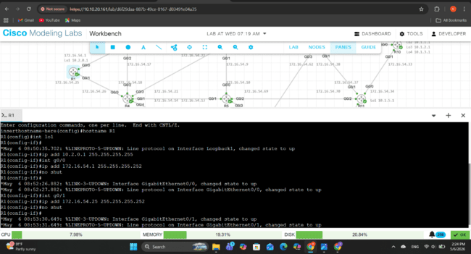
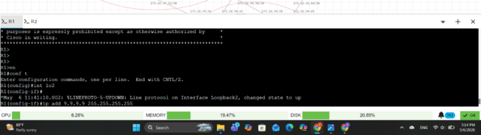
OSPF configurations
R1(config)#router ospf 1
R1(config-router)#network 172.16.54.0 0.0.0.3 area 0
R1(config-router)#network 172.16.54.24 0.0.0.3 area 0
R1(config-router)#network 10.2.0.1 255.255.255.255 area 0
R1(config-router)#do write
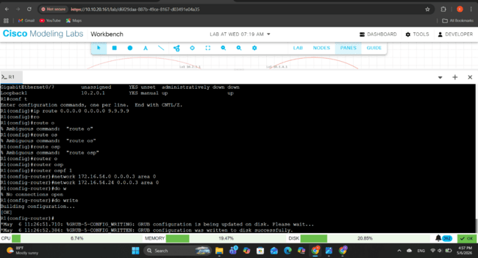
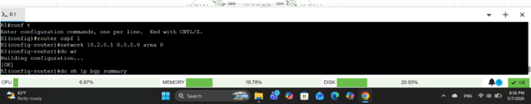
BGP configurations
R1(config)#router bgp 200
R1(config-router)#neighbor 10.2.1.1 remote-as 200
R1(config-router)# neighbor 10.2.1.1 update-source lo1
R1(config-router)# neighbor 10.2.1.1 next-hop-self
R1(config-router)# neighbor 10.2.2.1 remote-as 200
R1(config-router)# neighbor 10.2.1.1 update-source lo1
R1(config-router)# neighbor 10.2.2.1 next-hop-self
R1(config-router)# neighbor 10.2.3.1 remote-as 200
R1(config-router)# neighbor 10.2.3.1 update-source lo1
R1(config-router)# neighbor 10.2.3.1 next-hop-self
R1(config-router)# neighbor 10.2.4.1 remote-as 200
R1(config-router)# neighbor 10.2.4.1 update-source lo1
R1(config-router)# neighbor 10.2.4.1 next-hop-self
R1(config-router)# network 10.2.0.1 mask 255.255.255.255
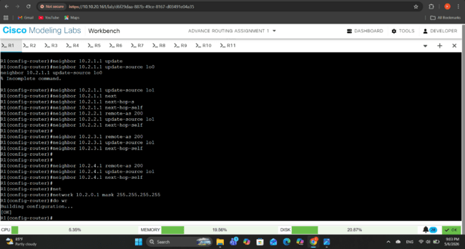

Router 2
IP configurations
R2(config)#interface lo1
R2(config-if)#ip address 10.2.1.1 255.255.255.255
R2(config)#interface g0/1
R2(config-if)#ip address 172.16.54.5 255.255.255.252
R2(config-if)#no shutdown
R2(config)#interface g0/0
R2(config-if)#ip address 172.16.54.2 255.255.255.252
R2(config-if)#no shutdown
R2(config)#interface g0/2
R2(config-if)#ip address 172.16.54.17 255.255.255.252
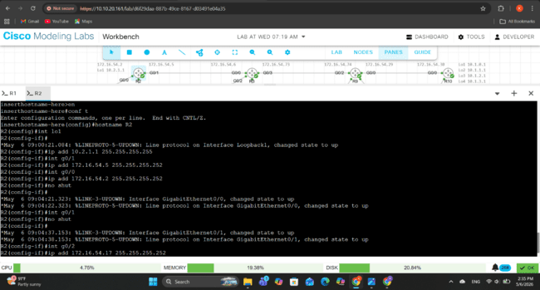
OSPF configurations
R2(config)#router ospf 1
R2(config-router)#network 172.16.54.0 0.0.0.3 area 0
R2(config-router)#network 172.16.54.4 0.0.0.3 area 0
R2(config-router)#network 172.16.54.16 0.0.0.3 area 0
R2(config-router)#network 10.2.1.1 0.0.0.0 area 0
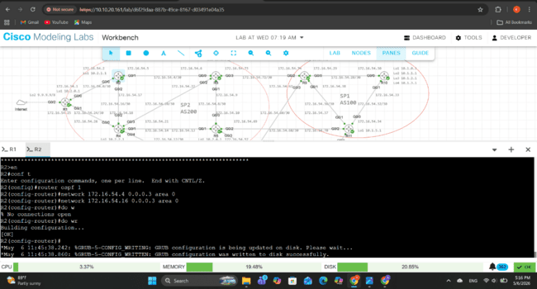
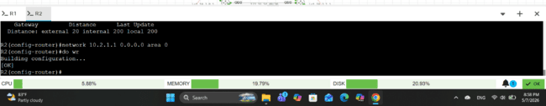
BGP configurations
R2(config)#router bgp 200
R2(config-router)#neighbor 10.2.0.1 remote-as 200
R2(config-router)# neighbor 10.2.0.1 update-source lo1
R2(config-router)# neighbor 10.2.0.1 next-hop-self
R2(config-router)#neighbor 10.2.2.1 remote-as 200
R2(config-router)# neighbor 10.2.2.1 update-source lo1
R2(config-router)# neighbor 10.2.2.1 next-hop-self
R2(config-router)#neighbor 10.2.4.1 remote-as 200
R2(config-router)# neighbor 10.2.4.1 update-source lo1
R2(config-router)# neighbor 10.2.4.1 next-hop-self
R2(config-router)#neighbor 10.2.3.1 remote-as 200
R2(config-router)# neighbor 10.2.3.1 update-source lo1
R2(config-router)# neighbor 10.2.3.1 next-hop-self
R2(config-router)#network 10.2.1.1 mask 255.255.255.255
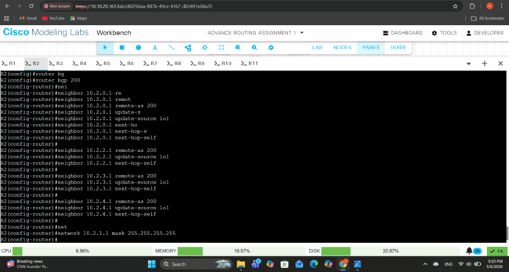

Router 3
IP configurations
R3(config)#interface lo1
R3(config-if)#ip address 10.2.3.1 255.255.255.255
R3(config)#interface g0/0
R3(config-if)#ip address 172.16.54.6 255.255.255.252
R3(config)#interface g0/1
R3(config-if)#ip address 172.16.54.9 255.255.255.252
R3(config)#interface g0/2
R3(config-if)#ip address 172.16.54.22 255.255.255.252
R3(config)#interface g0/3
R3(config-if)#ip address 172.16.54.73 255.255.255.252
R3(config)#interface range g0/0-3
R3(config-if-range)#no shutdown
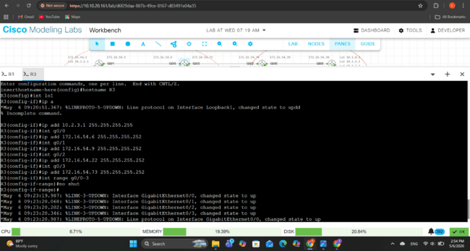
OSPF configurations
R3(config)#router ospf 1
R3(config-router)#network 172.16.54.8 0.0.0.3 area 0
R3(config-router)#network 172.16.54.4 0.0.0.3 area 0
R3(config-router)#network 172.16.54.20 0.0.0.3 area 0
R3(config-router)#network 172.16.54.72 0.0.0.3 area 0
R3(config-router)#network 10.2.3.1 0.0.0.0 area 0
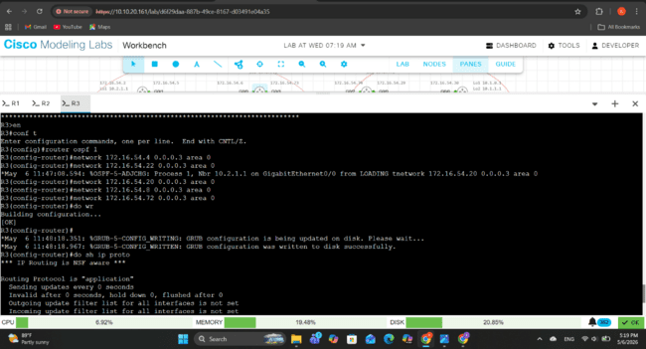
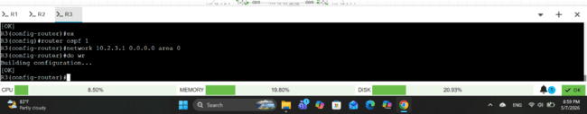
BGP configurations
R3(config)#router bgp 200
R3(config-router)#neighbor 10.2.0.1 remote-as 200
R3(config-router)# neighbor 10.2.0.1 update-source lo1
R3(config-router)# neighbor 10.2.0.1 next-hop-self
R3(config-router)#neighbor 10.2.2.1 remote-as 200
R3(config-router)# neighbor 10.2.2.1 update-source lo1
R3(config-router)# neighbor 10.2.2.1 next-hop-self
R3(config-router)#neighbor 10.2.1.1 remote-as 200
R3(config-router)# neighbor 10.2.1.1 update-source lo1
R3(config-router)# neighbor 10.2.1.1 next-hop-self
R3(config-router)#neighbor 10.2.4.1 remote-as 200
R3(config-router)# neighbor 10.2.4.1 update-source lo1
R3(config-router)# neighbor 10.2.4.1 next-hop-self
R3(config-router)#neighbor 10.1.4.1 remote-as 100
R3(config-router)#network 10.2.3.1 mask 255.255.255.255
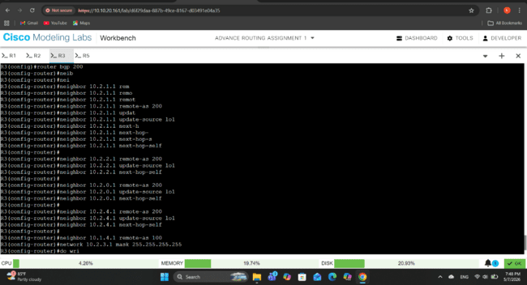

Router 4
R4(config)#interface lo1
R4(config-if)#ip address 10.2.2.1 255.255.255.255
R4(config)#interface g0/0
R4(config-if)#ip address 172.16.54.26 255.255.255.252
R4(config)#interface g0/1
R4(config-if)#ip address 172.16.54.14 255.255.255.252
R4(config)#interface g0/2
R4(config-if)#ip address 172.16.54.18 255.255.255.252
R4(config)#interface g0/3
R4(config-if)#ip address 172.16.54.21 255.255.255.252
R4(config)#interface g0/4
R4(config-if)#ip address 172.16.54.53 255.255.255.252
R4(config)#interface range g0/0-4
R4(config-if-range)#no shutdown
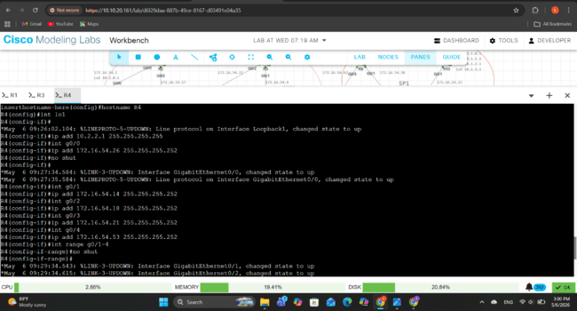
OSPF configurations
R4(config)#router ospf 1
R4(config-router)#network 172.16.54.24 0.0.0.3 area 0
R4(config-router)#network 172.16.54.16 0.0.0.3 area 0
R4(config-router)#network 172.16.54.12 0.0.0.3 area 0
R4(config-router)#network 172.16.54.52 0.0.0.3 area 0
R4(config-router)#network 172.16.54.52 0.0.0.3 area 0
R4(config-router)#network 10.2.2.1 0.0.0.0 area 0
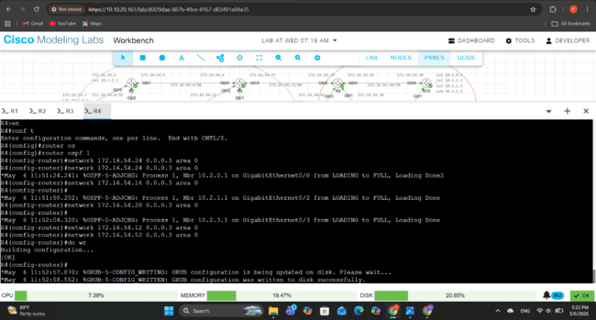
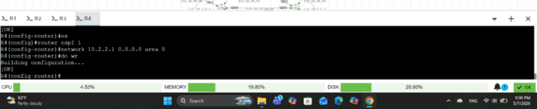
BGP configurations
R4(config)#router bgp 200
R4(config-router)#neighbor 10.2.0.1 remote-as 200
R4(config-router)# neighbor 10.2.0.1 update-source lo1
R4(config-router)# neighbor 10.2.0.1 next-hop-self
R4(config-router)#neighbor 10.2.1.1 remote-as 200
R4(config-router)# neighbor 10.2.1.1 update-source lo1
R4(config-router)# neighbor 10.2.1.1 next-hop-self
R4(config-router)#neighbor 10.2.3.1 remote-as 200
R4(config-router)# neighbor 10.2.3.1 update-source lo1
R4(config-router)# neighbor 10.2.3.1 next-hop-self
R4(config-router)#neighbor 10.2.4.1 remote-as 200
R4(config-router)# neighbor 10.2.4.1 update-source lo1
R4(config-router)# neighbor 10.2.4.1 next-hop-self
R4(config-router)#neighbor 10.3.0.1 remote-as 100
R4(config-router)# neighbor 10.3.0.1 update-source lo1
R4(config-router)# neighbor 10.3.0.1 next-hop-self
R4(config-router)#network 10.2.2.1 mask 255.255.255.255
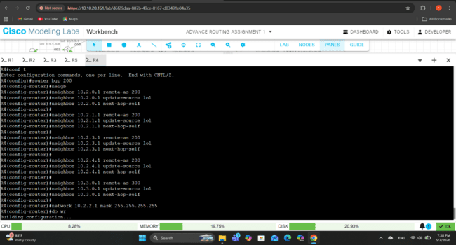

Router 5
IP configurations
R5(config)#interface lo1
R5(config-if)#ip address 10.2.4.1 255.255.255.255
R5(config)#interface g0/0
R5(config-if)#ip address 172.16.54.10 255.255.255.252
R5(config)#interface g0/1
R5(config-if)#ip address 172.16.54.13 255.255.255.252
R5(config)#interface g0/2
R5(config-if)#ip address 172.16.54.69 255.255.255.252
R5(config)#interface g0/3
R5(config-if)#ip address 172.16.54.57 255.255.255.252
R5(config)#interface range g0/0-3
R5(config-if-range)#no shutdown
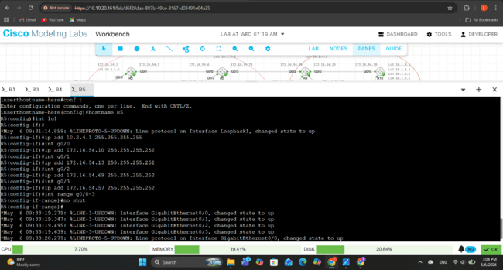
OSPF configurations
R5(config)#router ospf 1
R5(config-router)#network 172.16.54.8 0.0.0.3 area 0
R5(config-router)#network 172.16.54.12 0.0.0.3 area 0
R5(config-router)#network 172.16.54.56 0.0.0.3 area 0
R5(config-router)#network 172.16.54.68 0.0.0.3 area 0
R5(config-router)#network 10.2.4.1 0.0.0.0 area 0
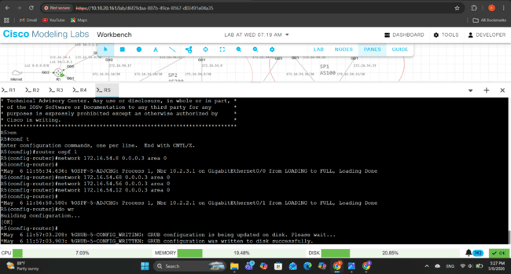
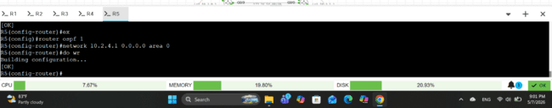
BGP configurations
R5(config)#router bgp 200
R5(config-router)#neighbor 10.2.0.1 remote-as 200
R5(config-router)# neighbor 10.2.0.1 update-source lo1
R5(config-router)# neighbor 10.2.0.1 next-hop-self
R5(config-router)#neighbor 10.2.1.1 remote-as 200
R5(config-router)# neighbor 10.2.1.1 update-source lo1
R5(config-router)# neighbor 10.2.1.1 next-hop-self
R5(config-router)#neighbor 10.2.3.1 remote-as 200
R5(config-router)# neighbor 10.2.3.1 update-source lo1
R5(config-router)# neighbor 10.2.3.1 next-hop-self
R5(config-router)#neighbor 10.1.5.1 remote-as 100
R5(config-router)# neighbor 10.1.5.1 update-source lo1
R5(config-router)# neighbor 10.1.5.1 next-hop-self
R5(config-router)#neighbor 10.3.1.1 remote-as 300
R5(config-router)# neighbor 10.3.1.1 update-source lo1
R5(config-router)# neighbor 10.3.1.1 next-hop-self
R5(config-router)#network 10.2.4.1 mask 255.255.255.255
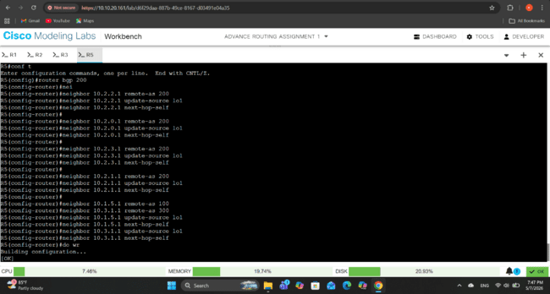

Router 6
IP configurations
R6(config)#interface lo1
R6(config-if)#ip address 10.3.0.1 255.255.255.255
R6(config)#interface g0/0
R6(config-if)#ip address 172.16.54.41 255.255.255.252
R6(config)#interface g0/1
R6(config-if)#ip address 172.16.54.49 255.255.255.252
R6(config)#interface g0/2
R6(config-if)#ip address 172.16.54.61 255.255.255.252
R6(config)#interface g0/3
R6(config-if)#ip address 172.16.54.54 255.255.255.252
R6(config)#interface range g0/0-3
R6(config-if-range)#no shutdown
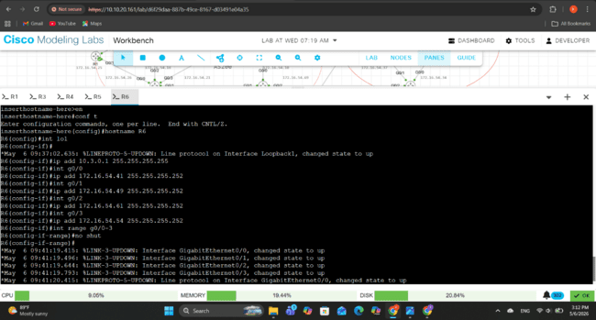
OSPF configurations
R6(config)#router ospf 1
R6(config-router)#network 172.16.54.60 0.0.0.3 area 0
R6(config-router)#network 172.16.54.40 0.0.0.3 area 0
R6(config-router)#network 172.16.54.48 0.0.0.3 area 0
R6(config-router)#network 172.16.54.52 0.0.0.3 area 0
R6(config-router)#network 10.3.0.1 0.0.0.0 area 0
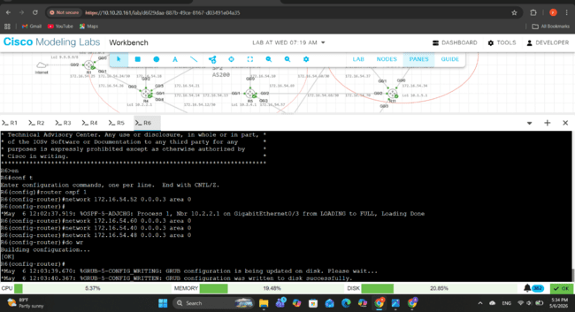
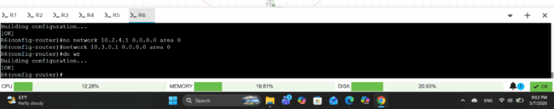
BGP configurations
R6(config)#router bgp 300
R6(config-router)#neighbor 10.3.1.1 remote-as 300
R6(config-router)# neighbor 10.3.1.1 update-source lo1
R6(config-router)# neighbor 10.3.1.1 next-hop-self
R6(config-router)#neighbor 10.3.2.1 remote-as 300
R6(config-router)# neighbor 10.3.2.1 update-source lo1
R6(config-router)# neighbor 10.3.2.1 next-hop-self
R6(config-router)#neighbor 10.2.2.1 remote-as 200
R6(config-router)# neighbor 10.2.2.1 update-source lo1
R6(config-router)# neighbor 10.2.2.1 next-hop-self
R6(config-router)#neighbor 10.1.4.1 remote-as 100
R6(config-router)# neighbor 10.1.4.1 update-source lo1
R6(config-router)# neighbor 10.1.4.1 next-hop-self
R6(config-router)#network 10.3.0.1 mask 255.255.255.255
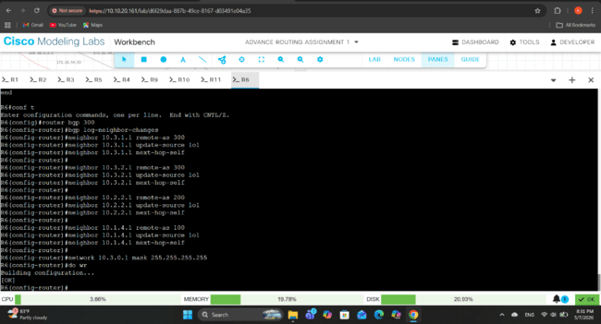

Router 7
IP configurations
R7(config)#interface lo1
R7(config-if)#ip address 10.3.1.1 255.255.255.255
R7(config)#interface g0/0
R7(config-if)#ip address 172.16.54.42 255.255.255.252
R7(config)#interface g0/1
R7(config-if)#ip address 172.16.54.45 255.255.255.252
R7(config)#interface g0/2
R7(config-if)#ip address 172.16.54.65 255.255.255.252
R7(config)#interface g0/3
R7(config-if)#ip address 172.16.54.58 255.255.255.252
R7(config)#interface range g0/0-3
R7(config-if-range)#no shutdown
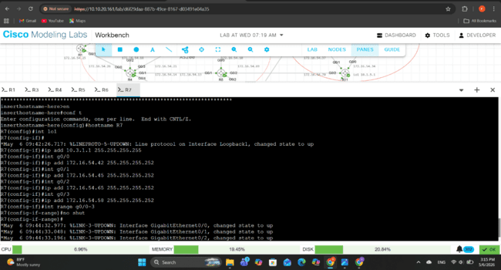
OSPF configuration
R7(config)#router ospf 1
R7(config-router)#network 172.16.54.64 0.0.0.3 area 0
R7(config-router)#network 172.16.54.40 0.0.0.3 area 0
R7(config-router)#network 172.16.54.44 0.0.0.3 area 0
R7(config-router)#network 172.16.54.56 0.0.0.3 area 0
R7(config-router)#network 10.3.1.1 0.0.0.0 area 0
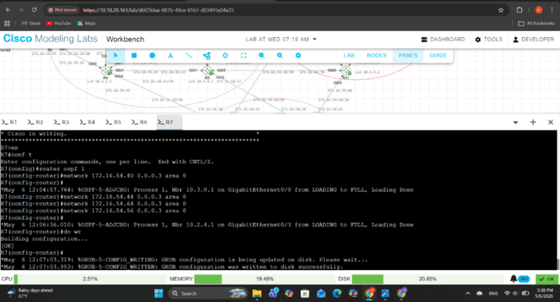
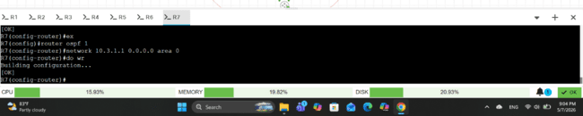
BGP configurations
R7(config)#router bgp 300
R7(config-router)#neighbor 10.3.0.1 remote-as 300
R7(config-router)# neighbor 10.3.0.1 update-source lo1
R7(config-router)# neighbor 10.3.0.1 next-hop-self
R7(config-router)#neighbor 10.3.2.1 remote-as 300
R7(config-router)# neighbor 10.3.2.1 update-source lo1
R7(config-router)# neighbor 10.3.2.1 next-hop-self
R7(config-router)#neighbor 10.2.4.1 remote-as 200
R7(config-router)# neighbor 10.2.4.1 update-source lo1
R7(config-router)# neighbor 10.2.4.1 next-hop-self
R7(config-router)#neighbor 10.1.5.1 remote-as 100
R7(config-router)# neighbor 10.1.5.1 update-source lo1
R7(config-router)# neighbor 10.1.5.1 next-hop-self
R7(config-router)#network 10.3.1.1 mask 255.255.255.255
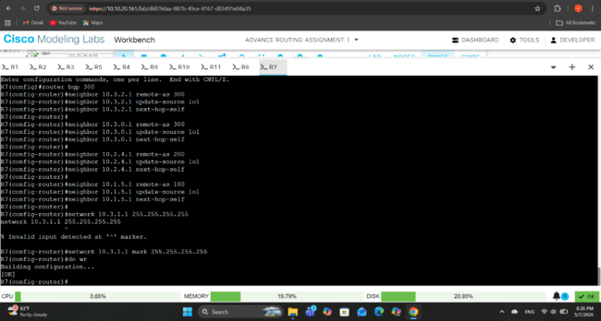

Router 8
IP configurations
R8(config)#interface lo1
R8(config-if)#ip address 10.3.2.1 255.255.255.255
R8(config)#interface g0/0
R8(config-if)#ip address 172.16.54.46 255.255.255.252
R8(config-if)#no shutdown
R8(config)#interface g0/1
R8(config-if)#ip address 172.16.54.50 255.255.255.252
R8(config-if)#no shutdown
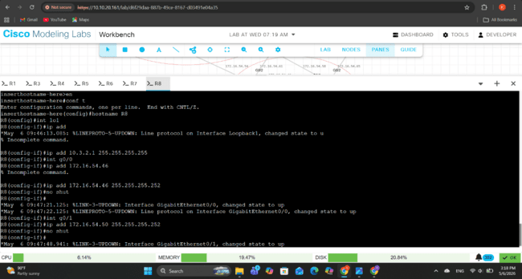
OSPF configurations
R8(config)#router ospf 1
R8(config-router)#network 172.16.54.48 0.0.0.3 area 0
R8(config-router)#network 172.16.54.44 0.0.0.3 area 0
R8(config-router)#network 10.3.2.1 0.0.0.0 area 0
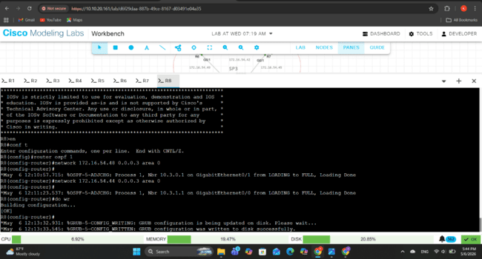
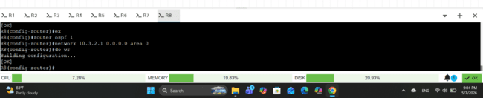
BGP configurations
R8(config)#router bgp 300
R8(config-router)#neighbor 10.3.0.1 remote-as 300
R8(config-router)# neighbor 10.3.0.1 update-source lo1
R8(config-router)# neighbor 10.3.0.1 next-hop-self
R8(config-router)#neighbor 10.3.1.1 remote-as 300
R8(config-router)# neighbor 10.3.1.1 update-source lo1
R8(config-router)# neighbor 10.3.1.1 next-hop-self
R8(config-router)#network 10.3.2.1 mask 255.255.255.255
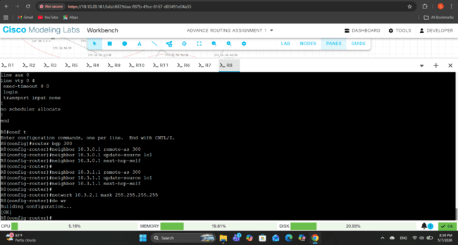

Router 9
IP configurations
R9(config)#interface lo1
R9(config-if)#ip address 10.1.4.1 255.255.255.255
R9(config)#interface g0/0
R9(config-if)#ip address 172.16.54.29 255.255.255.252
R9(config)#interface g0/1
R9(config-if)#ip address 172.16.54.38 255.255.255.252
R9(config)#interface g0/2
R9(config-if)#ip address 172.16.54.74 255.255.255.252
R9(config)#interface g0/3
R9(config-if)#ip address 172.16.54.62 255.255.255.252
R9(config)#interface range g0/0-3
R9(config-if-range)#no shutdown
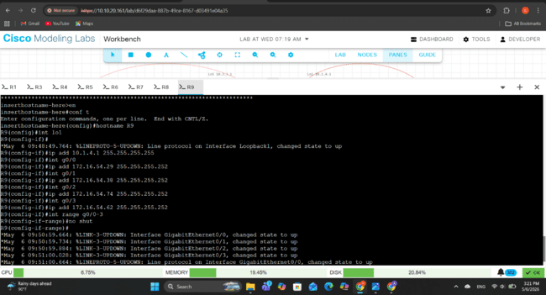
OSPF configuration
R9(config)#router ospf 1
R9(config-router)#network 172.16.54.72 0.0.0.3 area 0
R9(config-router)#network 172.16.54.60 0.0.0.3 area 0
R9(config-router)#network 172.16.54.36 0.0.0.3 area 0
R9(config-router)#network 172.16.54.28 0.0.0.3 area 0
R9(config-router)#network 10.1.4.1 0.0.0.0 area 0
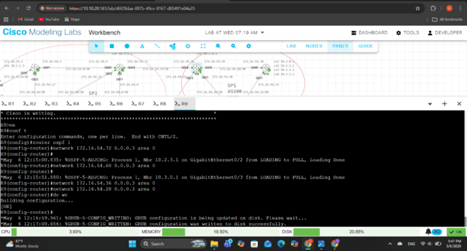
BGP configurations
R9(config)#router bgp 100
R9(config-router)#neighbor 10.2.3.1 remote-as 200
R9(config-router)# neighbor 10.2.3.1 update-source lo1
R9(config-router)# neighbor 10.2.3.1 next-hop-self
R9(config-router)#neighbor 10.3.0.1 remote-as 300
R9(config-router)# neighbor 10.3.0.1 update-source lo1
R9(config-router)# neighbor 10.3.0.1 next-hop-self
R9(config-router)#neighbor 10.1.0.1 remote-as 100
R9(config-router)# neighbor 10.1.0.1 update-source lo1
R9(config-router)# neighbor 10.1.0.1 next-hop-self
R9(config-router)#neighbor 10.1.5.1 remote-as 100
R9(config-router)# neighbor 10.1.5.1 update-source lo1
R9(config-router)# neighbor 10.1.5.1 next-hop-self
R9(config-router)#network 10.1.4.1 mask 255.255.255.255
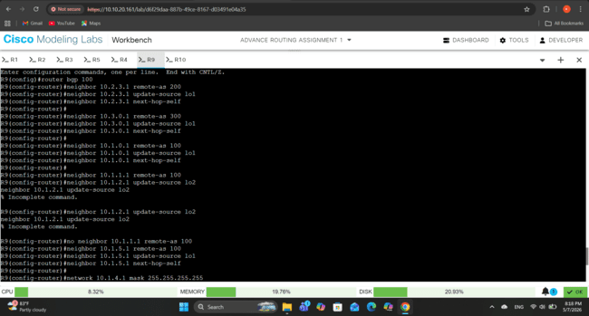

Router 10
IP configurations
R10(config)#interface lo1
R10(config-if)#ip address 10.1.0.1 255.255.255.255
R10(config)#interface lo2
R10(config-if)#ip address 10.1.1.1 255.255.255.255
R10(config)#interface lo3
R10(config-if)#ip address 10.1.2.1 255.255.255.255
R10(config)#interface lo4
R10(config-if)#ip address 10.1.3.1 255.255.255.255
R10(config)#interface g0/0
R10(config-if)#ip address 172.16.54.30 255.255.255.252
R10(config-if)#no shutdown
R10(config)#interface g0/1
R10(config-if)#ip address 172.16.54.33 255.255.255.252
R10(config-if)#no shutdown
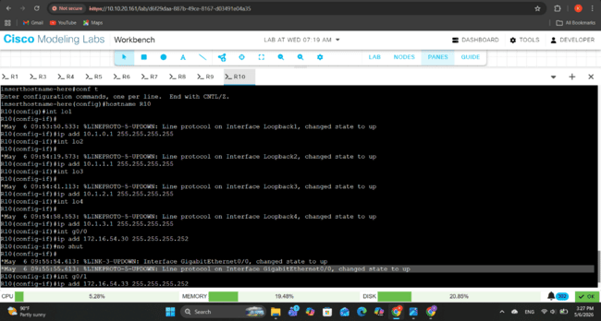
OSPF configuration
R10(config)#router ospf 1
R10(config-router)#network 172.16.54.28 0.0.0.3 area 0
R10(config-router)#network 172.16.54.32 0.0.0.3 area 0
R10(config-router)#network 10.1.0.1 0.0.0.0 area 0
R10(config-router)#network 10.1.1.1 0.0.0.0 area 0
R10(config-router)#network 10.1.2.1 0.0.0.0 area 0
R10(config-router)#network 10.1.3.1 0.0.0.0 area 0

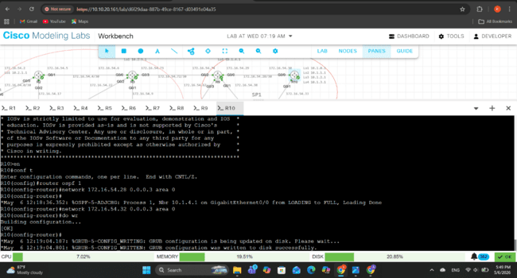
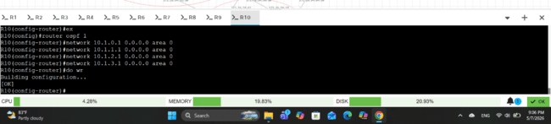
BGP configurations
R10(config)#router bgp 100
R10(config-router)#neighbor 10.1.5.1 remote-as 100
R10(config-router)# neighbor 10.1.5.1 update-source lo1
R10(config-router)# neighbor 10.1.5.1 next-hop-self
R10(config-router)#neighbor 10.1.4.1 remote-as 100
R10(config-router)# neighbor 10.1.4.1 update-source lo1
R10(config-router)# neighbor 10.1.4.1 next-hop-self
R10(config-router)#network 10.1.0.1 mask 255.255.255.255
R10(config-router)#network 10.1.1.1 mask 255.255.255.255
R10(config-router)#network 10.1.2.1 mask 255.255.255.255
R10(config-router)#network 10.1.3.1 mask 255.255.255.255
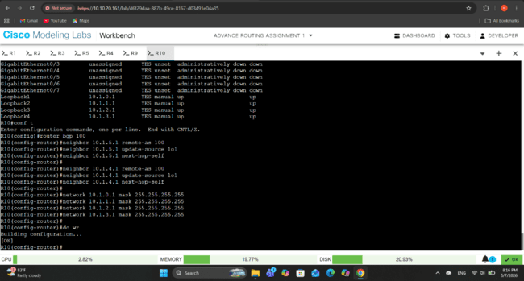

Router 11
IP configurations
R11(config)#interface lo1
R11(config-if)#ip address 10.1.5.1 255.255.255.255
R11(config)#interface g0/0
R11(config-if)#ip address 172.16.54.34 255.255.255.252
R11(config)#interface g0/1
R11(config-if)#ip address 172.16.54.37 255.255.255.252
R11(config)#interface g0/2
R11(config-if)#ip address 172.16.54.70 255.255.255.252
R11(config)#interface g0/3
R11(config-if)#ip address 172.16.54.66 255.255.255.252
R11(config)#interface range g0/0-3
R11(config-if-range)#no shutdown
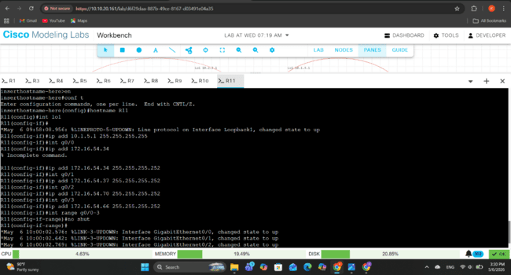
OSPF configuration
R11(config)#router ospf 1
R11(config-router)#network 172.16.54.36 0.0.0.3 area 0
R11(config-router)#network 172.16.54.32 0.0.0.3 area 0
R11(config-router)#network 172.16.54.68 0.0.0.3 area 0
R11(config-router)#network 172.16.54.64 0.0.0.3 area 0
R11(config-router)#network 10.1.5.1 0.0.0.0 area 0
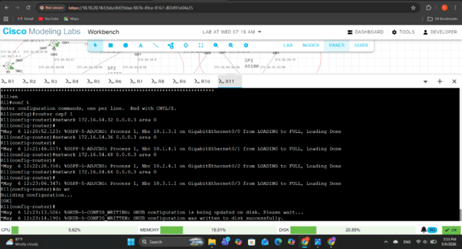
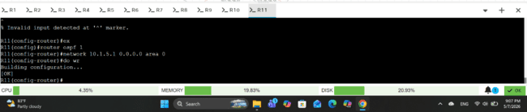
BGP configurations
R11(config)#router bgp 100
R11(config-router)#neighbor 10.1.0.1 remote-as 100
R11(config-router)# neighbor 10.1.0.1 update-source lo1
R11(config-router)# neighbor 10.1.0.1 next-hop-self
R11(config-router)#neighbor 10.1.4.1 remote-as 100
R11(config-router)# neighbor 10.1.4.1 update-source lo1
R11(config-router)# neighbor 10.1.4.1 next-hop-self
R11(config-router)#neighbor 10.2.4.1 remote-as 200
R11(config-router)# neighbor 10.2.4.1 update-source lo1
R11(config-router)# neighbor 10.2.4.1 next-hop-self
R11(config-router)#neighbor 10.3.1.1 remote-as 300
R11(config-router)# neighbor 10.3.1.1 update-source lo1
R11(config-router)# neighbor 10.3.1.1 next-hop-self
R11(config-router)#network 10.1.5.1 mask 255.255.255.255
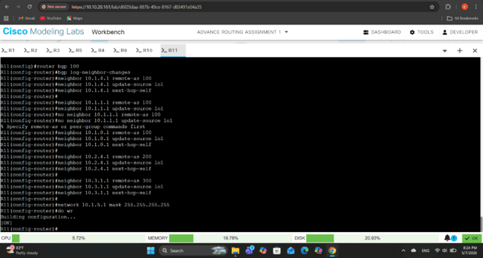

Comprehensive Test Plan
A comprehensive test plan was created to confirm the proper functioning, stability, and reliability of the deployed network infrastructure. Once the IP addressing, OSPF, iBGP, and eBGP setups were finished, the testing procedure was carried out. To make sure that all routers, routing protocols, and autonomous systems functioned properly in accordance with the network design specifications, a variety of verification techniques and diagnostic commands were employed.

- OSPF Neighbor Verification
Command – R# show ip ospf neighbor
This command used to verify whether routers successfully formed OSPF neighbor relationships with directly connected routers.
The neighbor state should appear as FULL, indicating successful OSPF adjacency formation between routers.

- OSPF Route Table Verification
Command – R# show ip route ospf
This command used to verify that OSPF successfully learned and distributed routes throughout the network.
Routes learned through OSPF should appear in the routing table with the code “O”.

- BGP Neighbor Verification
Command – R# show ip bgp summary
Using this command, it verifies successful establishment of iBGP and eBGP neighbor relationships.
All BGP neighbors should appear in the Established state.

- BGP Route Verification
Command – R# show ip bgp
This command will verify that routers successfully learned and exchanged BGP routes.
Remote autonomous system networks and loopback routes should appear in the BGP routing table.

- Connectivity Verification
Command – R# ping <destination IP>
The ping test used to verify end-to-end connectivity between routers and loopback interfaces.
Successful replies should be received from destination routers.

Test Results for Test Plan
The comprehensive test plan verified the functionality, connectivity, routing behavior, and stability of the network topology. The testing process also helped identify configuration issues and confirm successful route exchange between autonomous systems.
- The show ip ospf neighbor command successfully confirmed that the physical interfaces, IP addressing, and OSPF configurations are functioning correctly. This also ensured that routers could exchange routing information required for loopback reachability and BGP support.

- The show ip route ospf command confirmed that routers learned remote networks and loopback addresses through OSPF. Since loopback interfaces are used for iBGP neighbor relationships, OSPF reachability is necessary for successful BGP communication.

- Using the show ip bgp summary command, confirmed that routers successfully formed BGP peer relationships both within AS and between different AS. It also verified that BGP sessions are operating correctly.

- The ping command showed proper route advertisement and route learning between AS100, AS200, and AS300. It also verified that BGP route propagation operated successfully across the topology.

Below screenshots show the outputs of test commands.
Test of Router 1
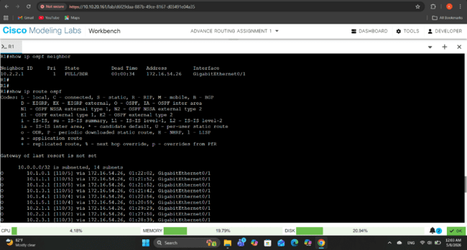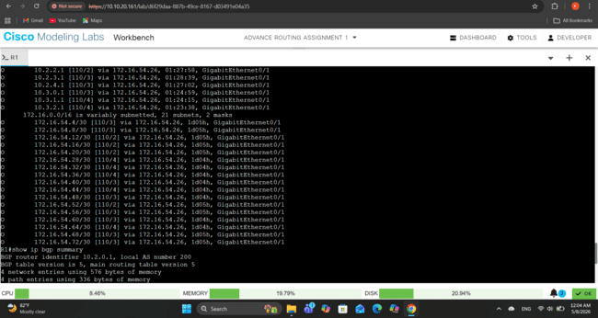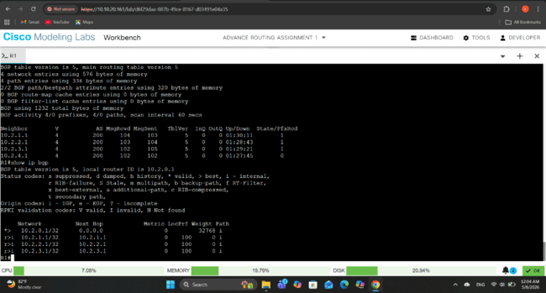

Test of Router 2
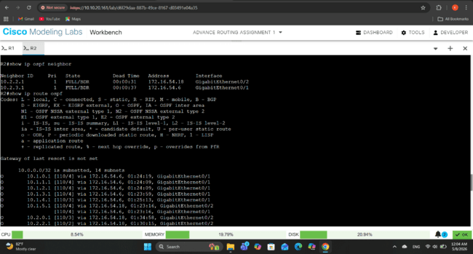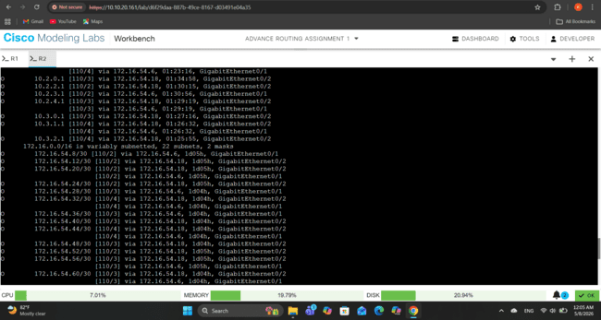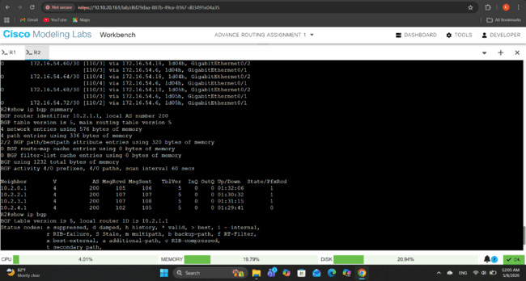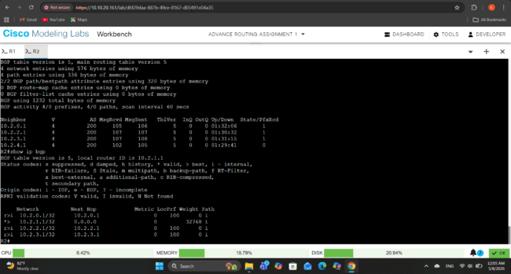

Test of Router 3
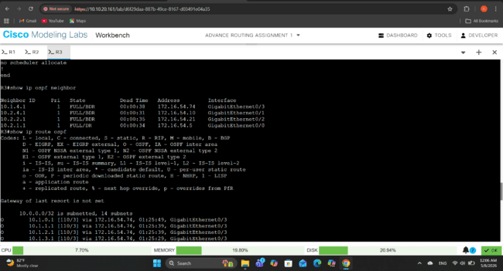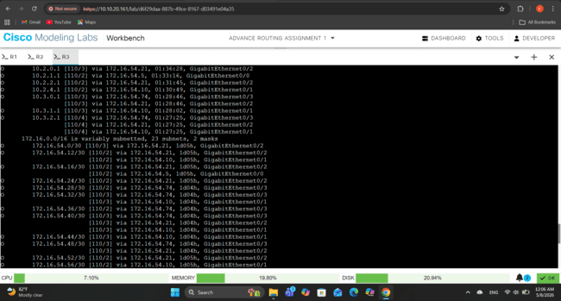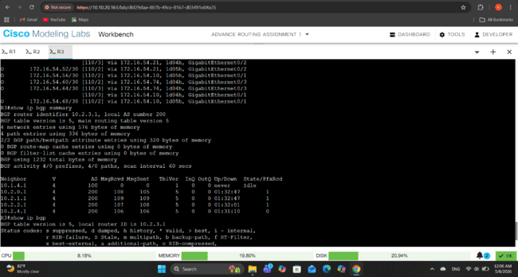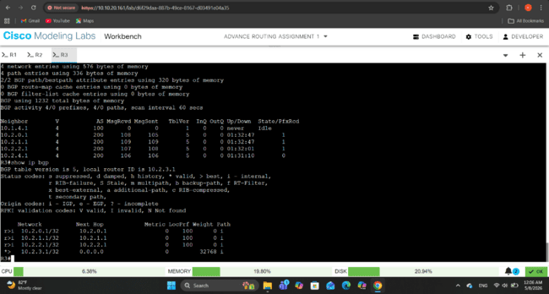

Test of Router 4
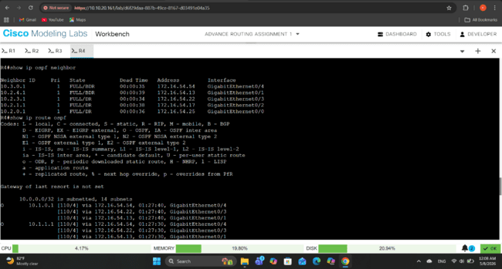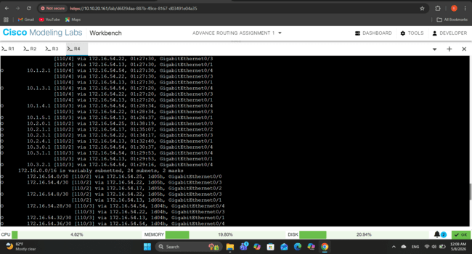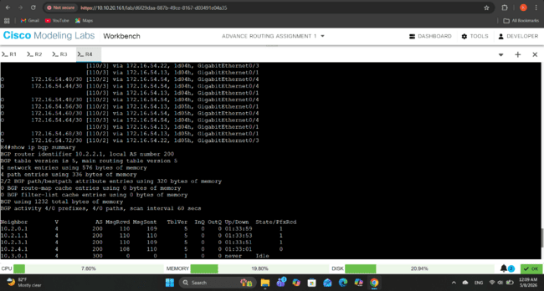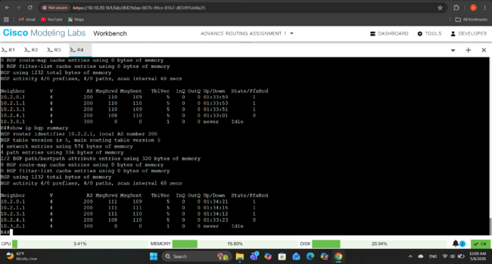

Test of Router 5
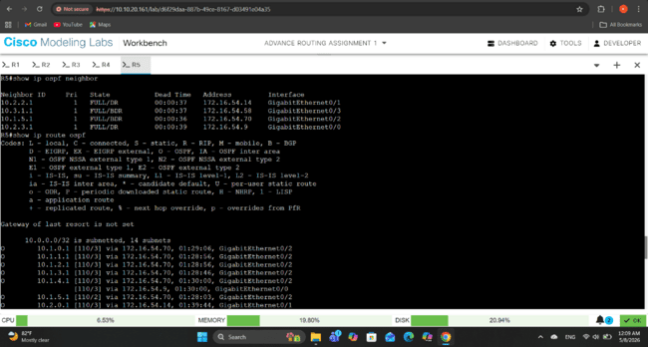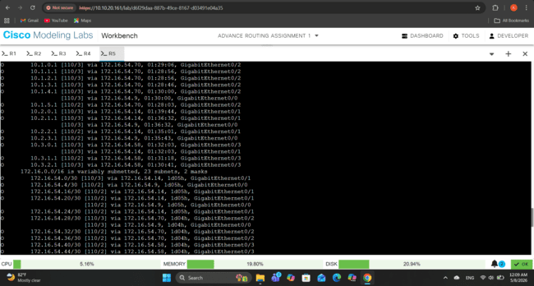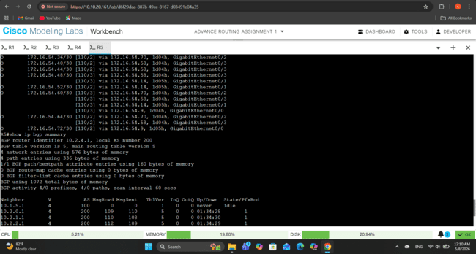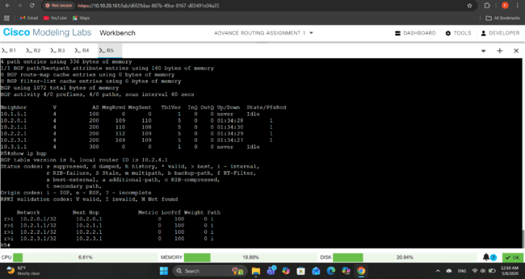

Test of Router 6
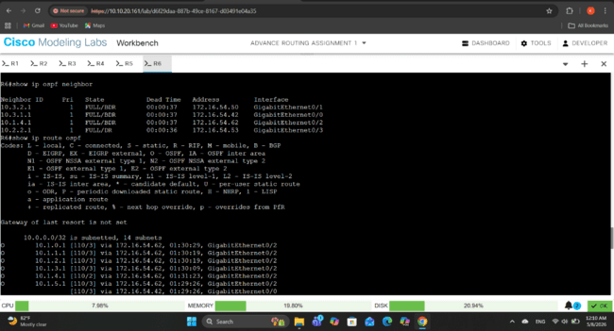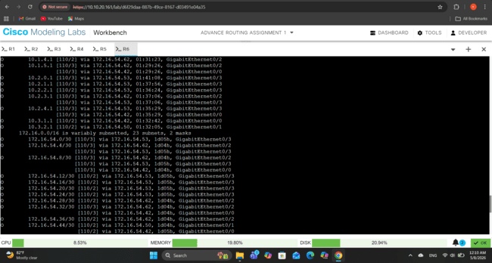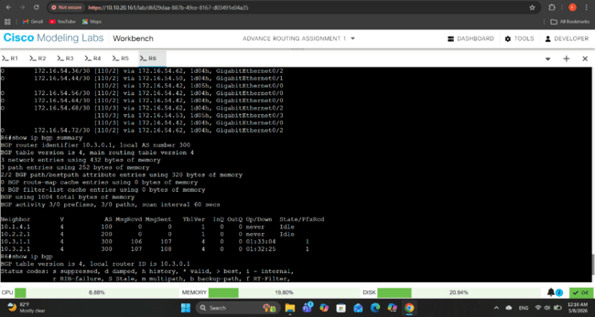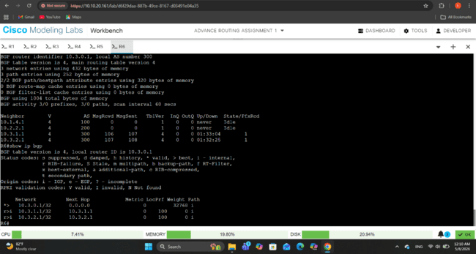

Test of Router 7
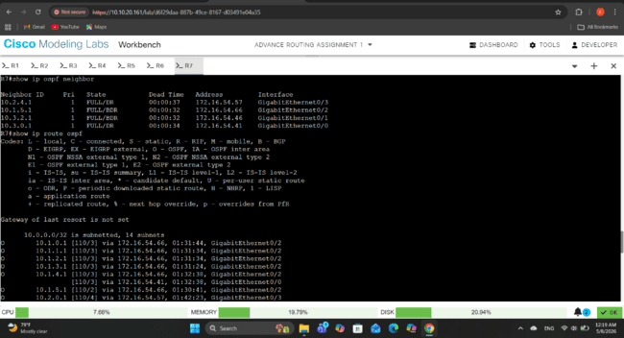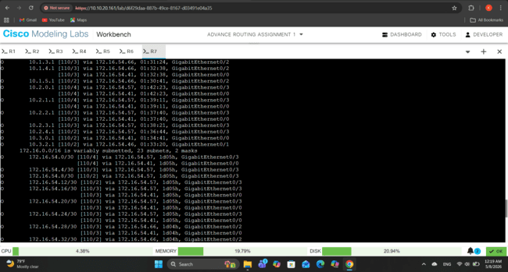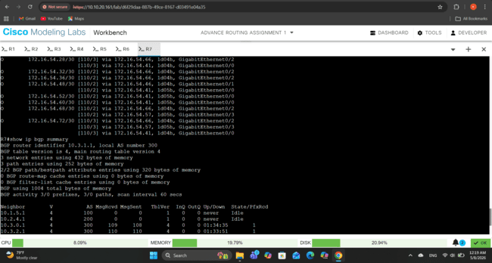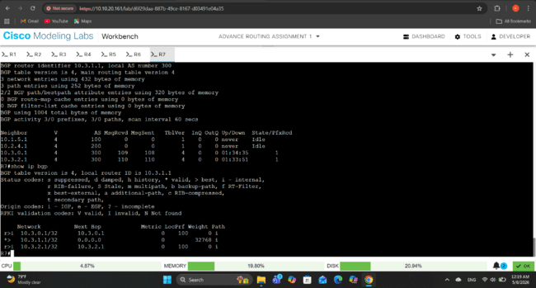

Test of Router 8
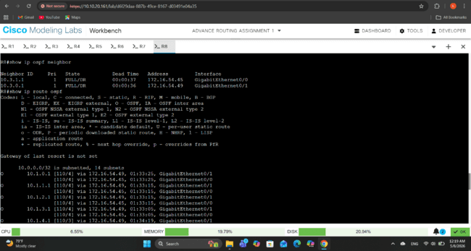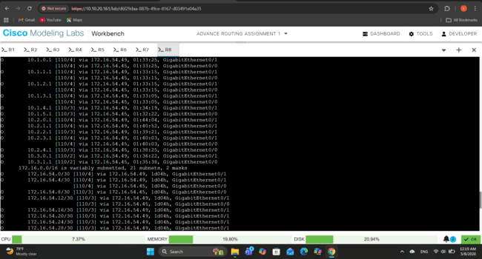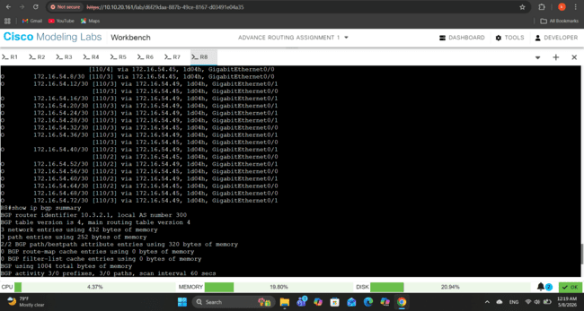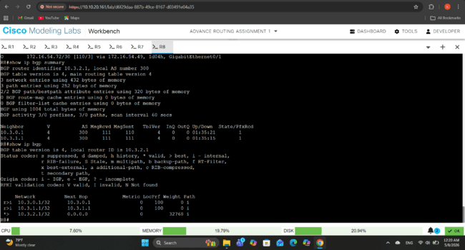

Test of Router 9
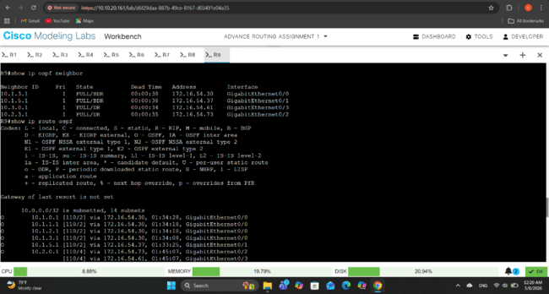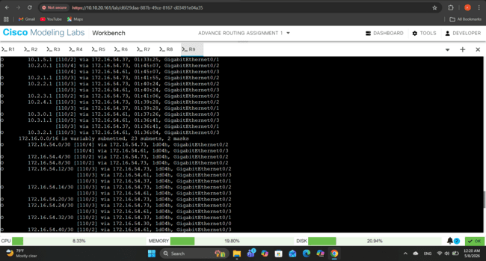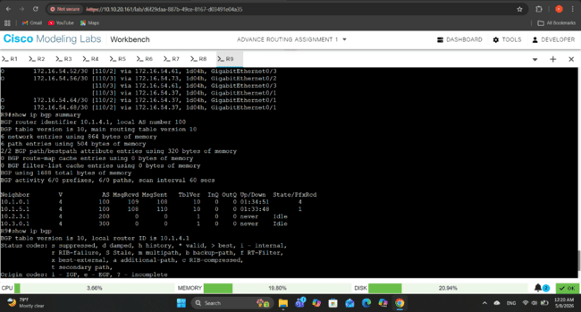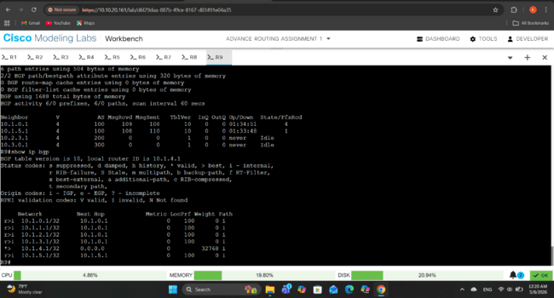

Test of Router 10
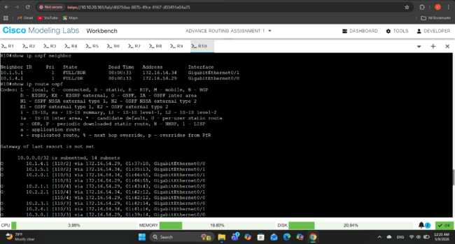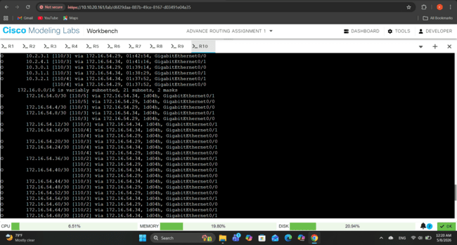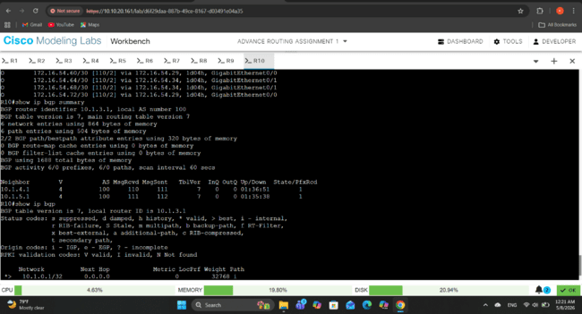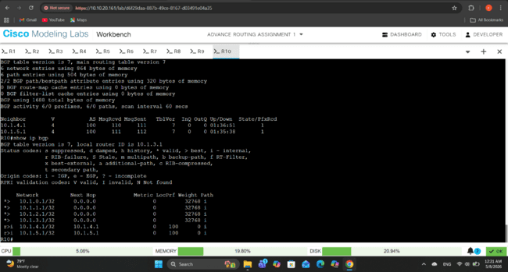

Test of Router 11
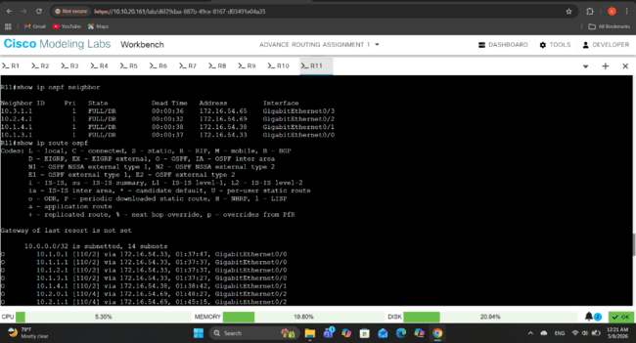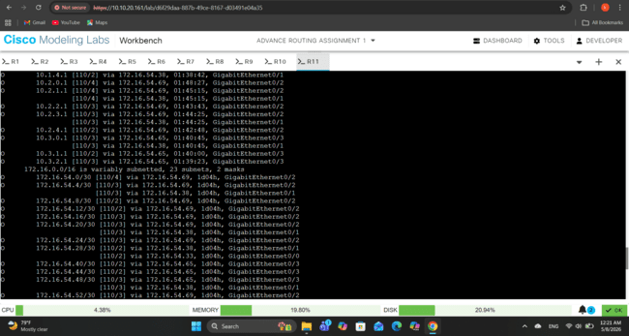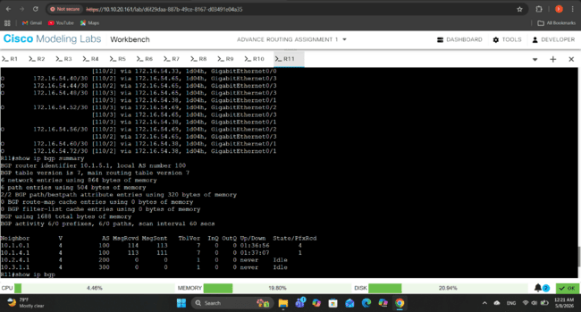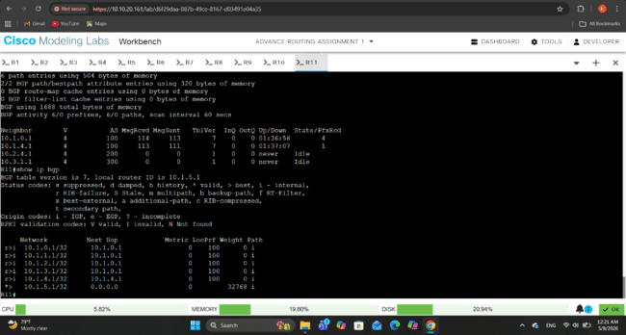

Test Results of The Ping Command
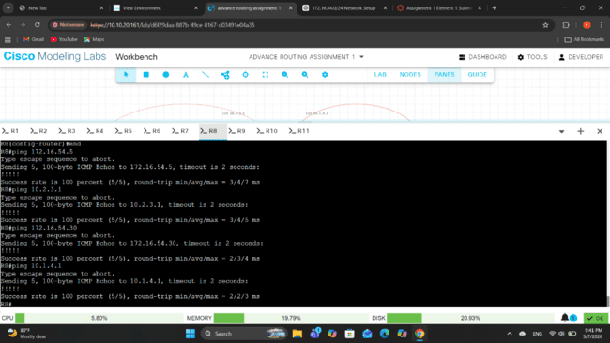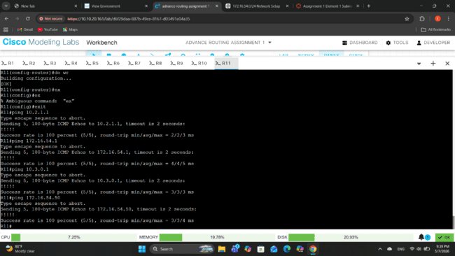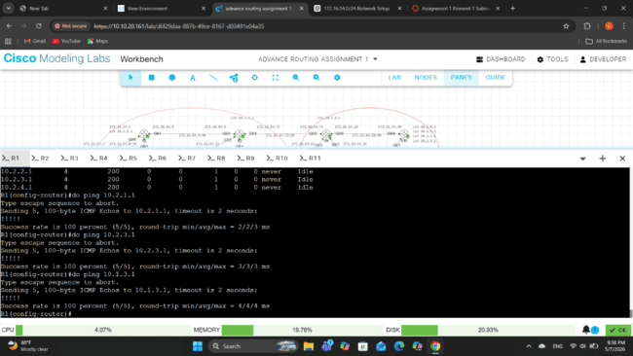

Conclusion
The comprehensive testing and verification process confirmed the successful implementation and operation of the network topology. Multiple testing methods showed the IP connectivity, OSPF functionality, iBGP and eBGP neighbor establishment, route propagation, and end-to-end communication across the network topology.
According to results of the test, OSPF successfully established neighbor relationships and distributed internal routing information throughout the network. BGP sessions between routers within the same autonomous systems and between different autonomous systems also successfully established and maintained. Additionally, routers correctly learned and exchanged routes through iBGP and eBGP, ensuring complete connectivity between AS100, AS200, and AS300.
Moreover, ping tests confirmed successful communication between interfaces and loopback addresses across multiple autonomous systems. Overall, the testing process verified that the network operated according to the assignment requirements while maintaining stable and reliable routing communication throughout the network.

